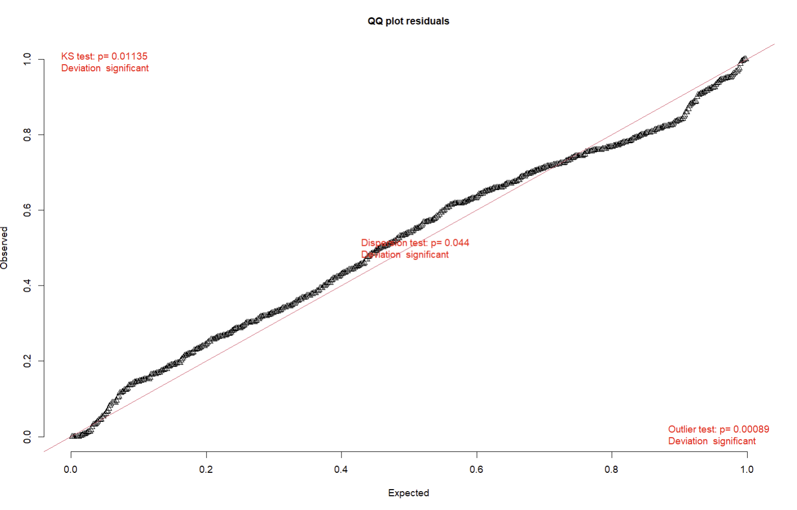
Model diagnostics were assessed using DHARMa simulated residuals. Residual distributions showed minor deviations from uniformity (Kolmogorov–Smirnov test, p < 0.05) and mild overdispersion, consistent with structured biological heterogeneity and large sample size. Visual inspection of residual plots indicated good overall model fit, with no evidence of systematic misspecification.
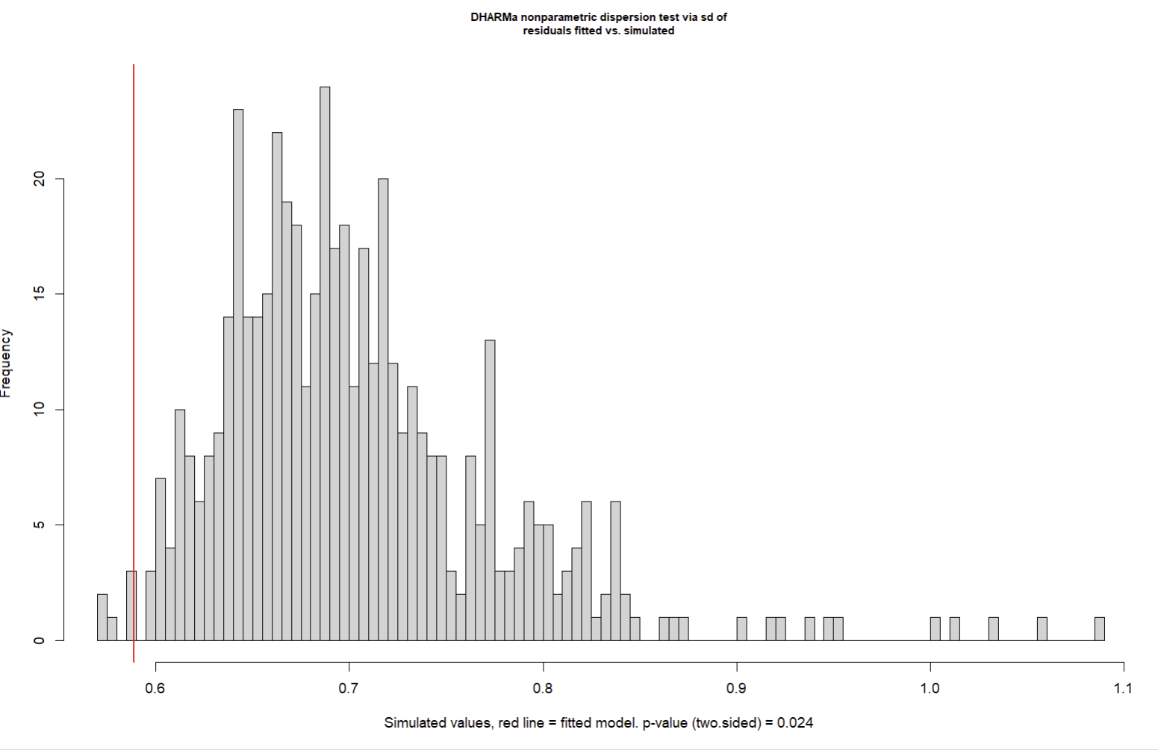
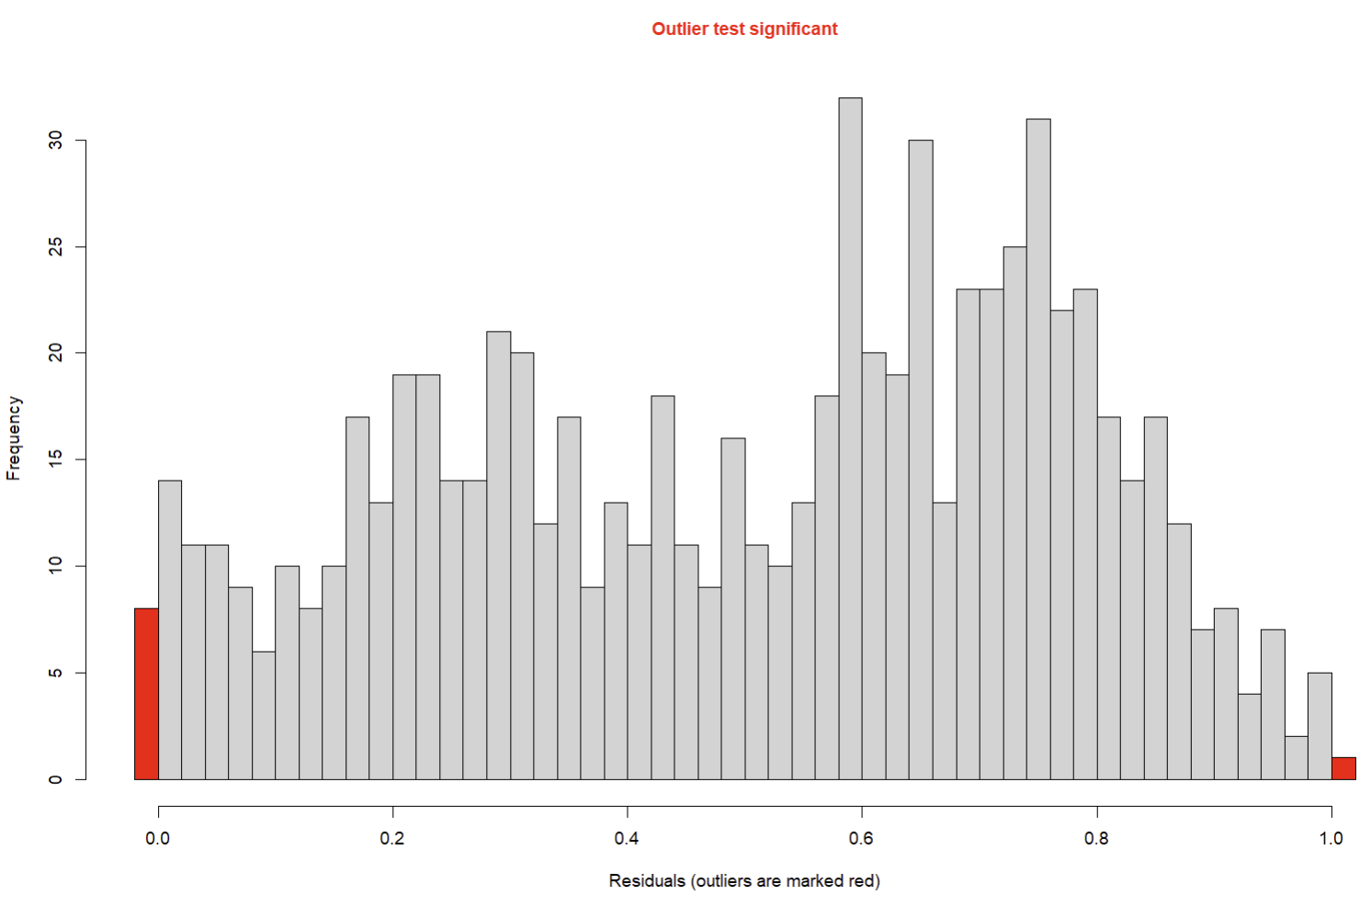
Asymptotic one-sample Kolmogorov-Smirnov test

data: simulationOutput$scaledResiduals
D = 0.080953, p-value = 0.0001119
alternative hypothesis: two-sided

> testDispersion(sim)

DHARMa nonparametric dispersion test via sd of residuals fitted vs. simulated

data: simulationOutput
dispersion = 0.83738, p-value = 0.024
alternative hypothesis: two.sided

> testOutliers(sim)

DHARMa outlier test based on exact binomial test with approximate expectations

data: sim
outliers at both margin(s) = 9, observations = 747, p-value = 0.003581
alternative hypothesis: true probability of success is not equal to 0.003992016
95 percent confidence interval:
0.005523596 0.022747558
sample estimates:
frequency of outliers (expected: 0.00399201596806387 )
0.01204819
Key figure dispersion = 0.84
That is mild under-dispersion, not over-dispersion.
Under-dispersion in beta models typically means:
- Responses are more constrained than the simulated null
- Often due to real biological bounds (motility proportions)
Model diagnostics based on DHARMa simulations indicated mild deviations from uniformity and slight under-dispersion, which are common in beta regression models fitted to bounded proportion data with strong biological structure. A small number of residual outliers were detected (<2% of observations), consistent with heterogeneous treatment responses. All models converged successfully with positive-definite Hessians, and results were robust to these deviations.
Discussion/Introduction notes
Suspended Particulate Matter (SPM) impacts kelp zoospore motility through multiple, separable mechanisms — not solely through light attenuation.
We have explicitly tested four mechanistic pathways, not a single proxy:
A. Optical pathway — light limitation
- Predictor: lux_exposure
- Mechanism: Reduced photon flux → altered photosensory / energy balance
- We are testing: Light reduction alone does not fully explain motility loss
B. Physical pathway — turbidity / particle load
- Predictor: ntu
- Mechanism: Increased suspended particles alter near-boundary hydrodynamics, collision frequency, and flagellar efficiency
- Key design strength: NTU varies independently of lux in parts of the experiment
C. Particulate identity pathway — size / surface / composition
- Predictor: toxin_exposure (particle type proxy)
- Mechanism: Different particle types (e.g. clay, brake dust, BaSO₄) impose different mechanical and surface-interaction constraints
D. Chemical pathway — dissolved or particle-associated chemistry
- Predictor: cu_ug_l (with toxin_exposure)
- Mechanism: Sub-lethal chemical interference with motility physiology, independent of shading or turbidity
SPM is therefore not a single predictor in our analysis.
It is a latent construct decomposed into measurable components.

Experiment 8.2 NTU
> range(df_8$ntu, na.rm = TRUE)
[1] 0 4144
> df_8 %>% count(toxin_exposure)
# A tibble: 2 × 2
toxin_exposure n
<chr> <int>
1 CONTROL 15
2 SPM 57
> summary(df_8$motility_ratio)
Min. 1st Qu. Median Mean 3rd Qu. Max.
0.05643 0.27382 0.30289 0.31402 0.36756 0.55385
bind_cols(wilson_ci(.$mobile, .$total)) %>%
+ rename(ci_low = lwr, ci_high = upr)
> sum_8
# A tibble: 9 × 8
toxin_exposure ntu n_reps mobile total motility ci_low ci_high
<chr> <dbl> <int> <dbl> <dbl> <dbl> <dbl> <dbl>
1 CONTROL 0 15 122875 820335 0.150 0.149 0.151
2 SPM 460 12 48670 131007 0.372 0.369 0.374
3 SPM 850 9 120017 309840 0.387 0.386 0.389
4 SPM 1184 9 130700 334294 0.391 0.389 0.393
5 SPM 1381 3 1247 4148 0.301 0.287 0.315
6 SPM 1473 9 82207 209580 0.392 0.390 0.394
7 SPM 1727 9 98241 254963 0.385 0.383 0.387
8 SPM 2763 3 1402 4560 0.307 0.294 0.321
9 SPM 4144 3 1606 5631 0.285 0.274 0.297

>

Spearman's rank correlation rho

data: df_8$ntu and df_8$motility_ratio
S = 62551, p-value = 0.9621
alternative hypothesis: true rho is not equal to 0
sample estimates:
rho
-0.00570515
Spearman’s rank correlation showed no association between turbidity and motile fraction (ρ = −0.006, p = 0.96, n = 72).
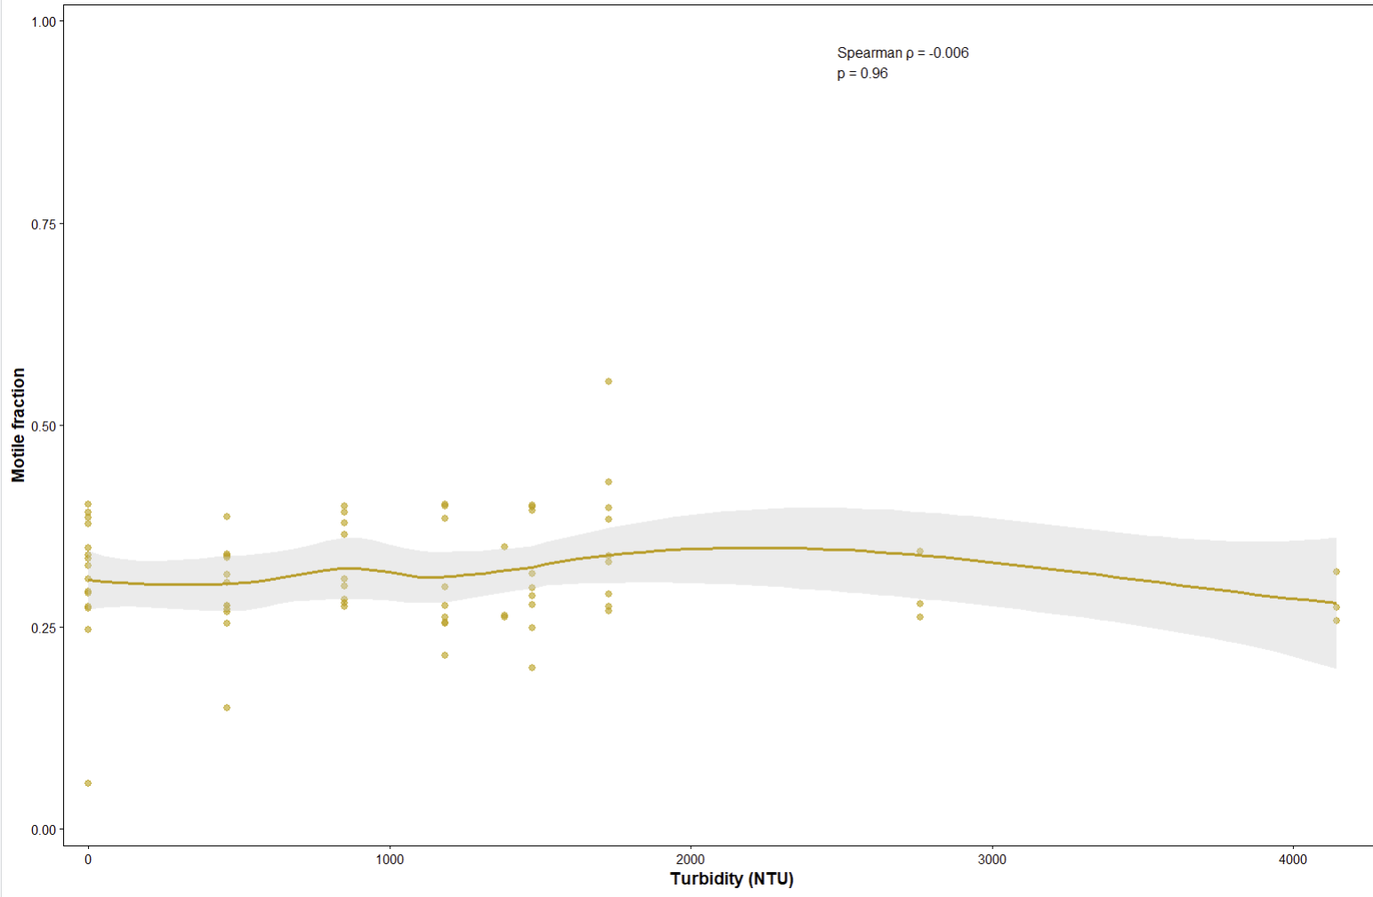
Figure 1 Effect of turbidity (NTU) on zoospore motile fraction in Laminaria digitata (Experiment 8.2). Zoospores were exposed for short-term duration across a turbidity gradient from 0 to 4144 NTU. Points represent individual replicate wells (n = 72). The solid line shows a loess-smoothed trend (visualization only; shaded area = 95% confidence interval). No relationship was detected between turbidity and motile fraction (Spearman’s ρ = −0.006, p = 0.96). Motility remained stable across the full turbidity range.
Even at extreme turbidity (4144 NTU), motility remains well within normal biological range.
Results
Short-term exposure to elevated turbidity did not reduce zoospore motility in L. digitata. Across the full gradient from 0 to 4144 NTU, motile fraction remained stable (median = 0.30; mean = 0.31). There was no evidence of a monotonic relationship between turbidity and motility (Spearman’s ρ = −0.006, p = 0.96). Visual inspection revealed no threshold or non-linear decline at higher turbidity levels. Motility under moderate turbidity (~100 NTU) was indistinguishable from clear-water controls. DOH!!!!!! Didn’t take Day into account redo!!!!!!
Discussion
Contrary to expectations that elevated suspended particles might impede flagellar propulsion or interfere with near-surface swimming behavior, turbidity alone did not impair zoospore motility under short-term exposure. Even at extremely high turbidity (4144 NTU), motile fraction remained within the natural biological range observed in controls. This suggests that light attenuation or particle presence, in isolation, is insufficient to disrupt active swimming in L. digitata zoospores. These findings indicate that previously reported recruitment impairments in turbid environments are unlikely to arise from direct suppression of swimming capacity, but may instead reflect secondary processes such as altered settlement surface properties, sediment deposition, or chemical interactions associated with specific particulate compositions.
